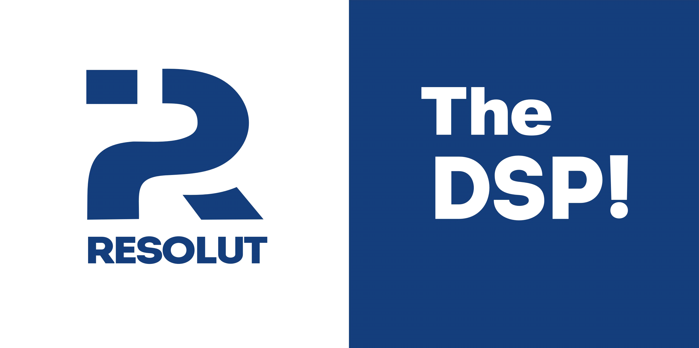

resolut src purpose

Remote controller Resolut SRC (Smart Remote Control) can be used jointly with audio processors Resolut for operational sound management in audio system, source selection, selection of configurations (presets), adjustment of subwoofer's level relatively acoustic systems and another settings which depend on software version.

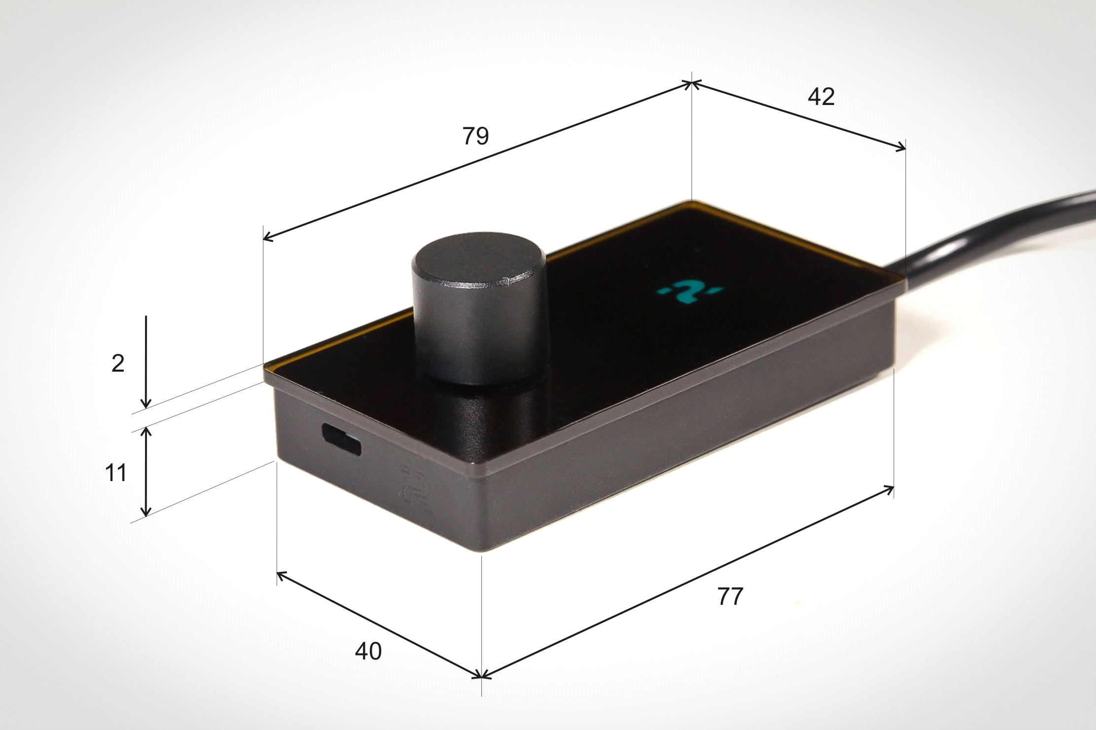

Delivery set

- Remote controller Resolut SRC – 1
- Metallic assembly bar -1
- Double-faced adhesive tape for screwless installation - 1
- Cable for remote controller's connection to processor – 1
- Coupler for remote controller's connecting to processor's for simplification -1

Сonnection remote controller to processor

Remote controller connects to processor through Control port. Use the cable from delivery set. Do not use third-party cables. Attention! Micro USB port, located on device side is only for service purposes! Do not connect any devices, it can cause damage for remote contoller, port is only for software's updating.

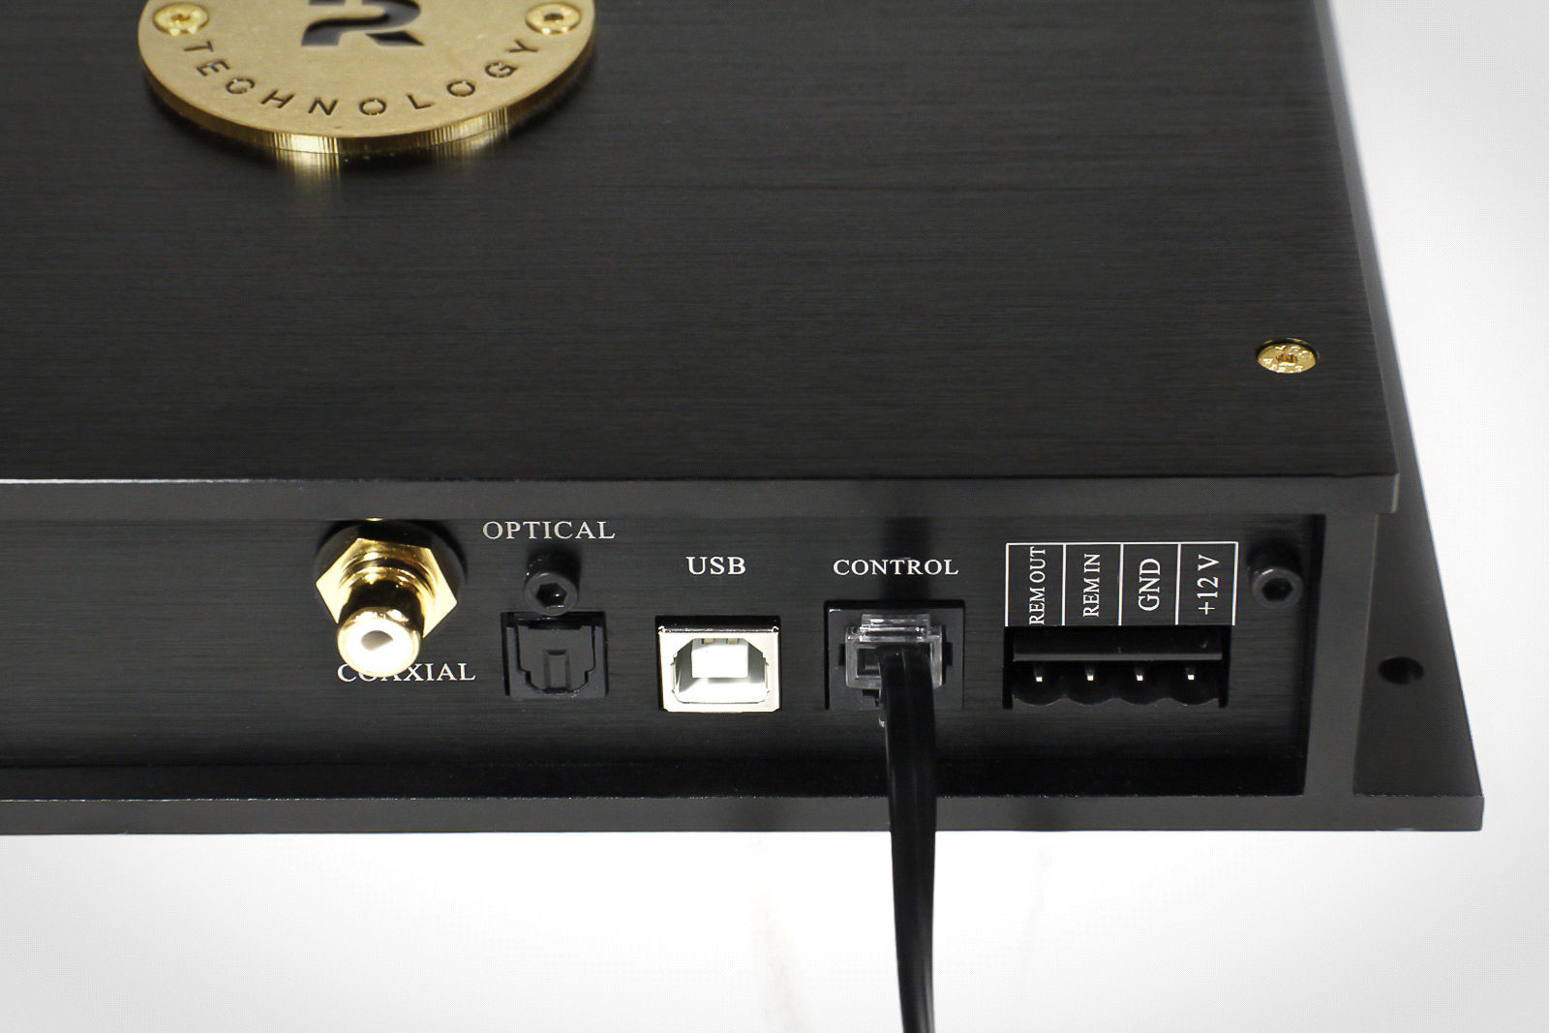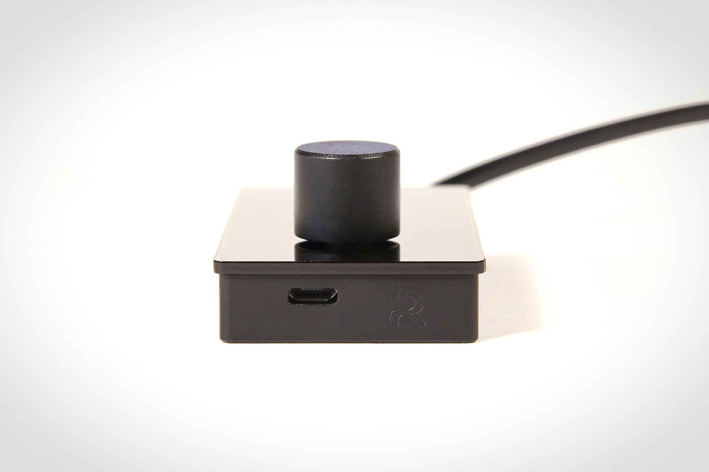

resolut src installation

Remote controller can be installed on a surface or by cut-in installation. Magnets on the back side of device and metallic assembly bar from delivery set intended for comfortable installation. Bar can be stowed in any suitable place easily and remote controller can be stowed on it in one move.

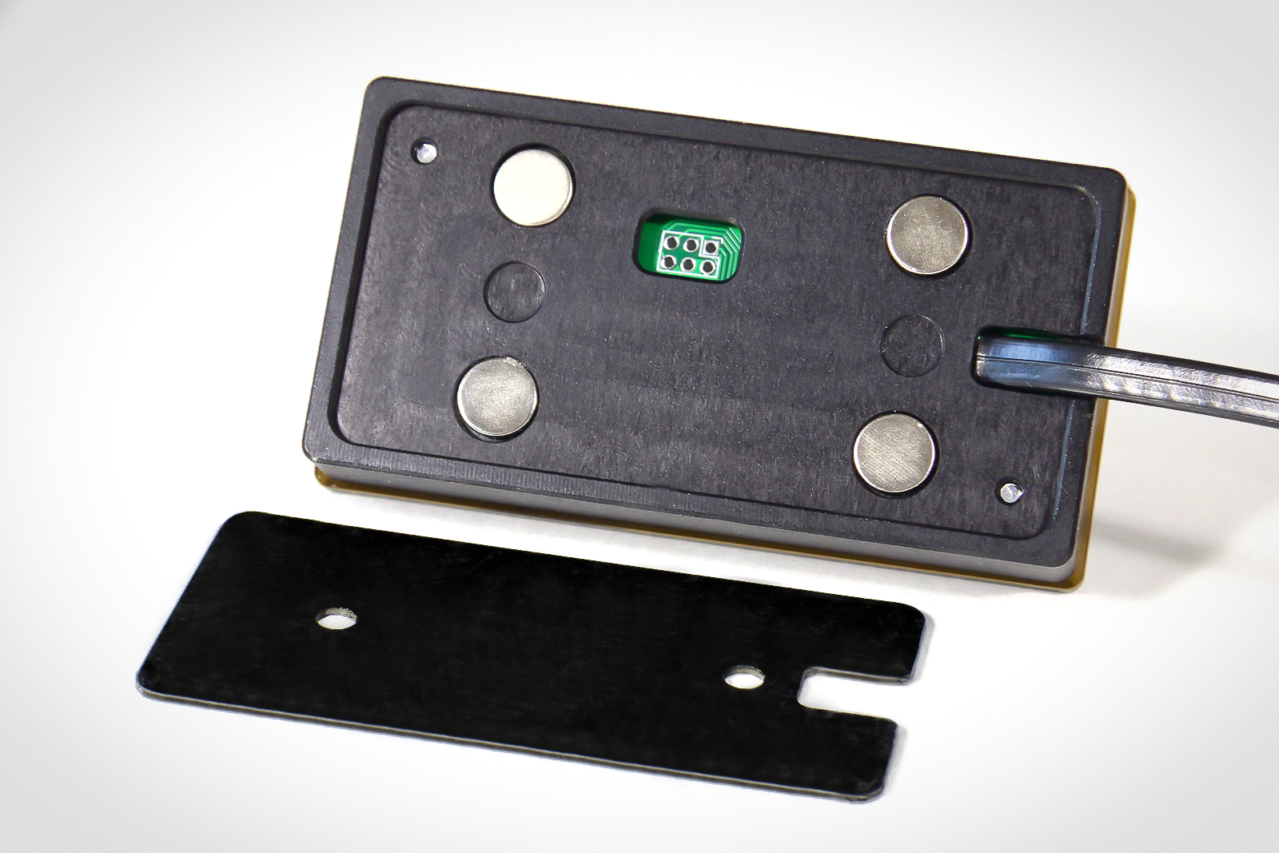

Use common sense and safety issue when choosing a place for remote controller. Operational management of audio system should not cause discomfort and should not disturb from driving car.

It is not recommended to install remote controller under sunlight, nearly warming elements and on places where it can be affected by water, it can cause damage to remote controller.

Be sure that while remote controller's installation and cabling it from processor there are not damaged elements of regular wiring, fuel, brake and another car systems. Do not wire outside the car, nearly sharp and heating elements. If necessary use the protective sleeve and corrugated tubes for mechanical cable protection. If cable crosses metallic partitions use rubber busches which can protect from grinding.

Remote controller has opportuity to choose screen's orientation. You can choose the most comfortable option of installation - with right or left encoder's location relatively screen. Screen's adjustment can be made by Resolut DSP Tool software, what is available on official web-site resolut-audio.ru in "Download" tab.

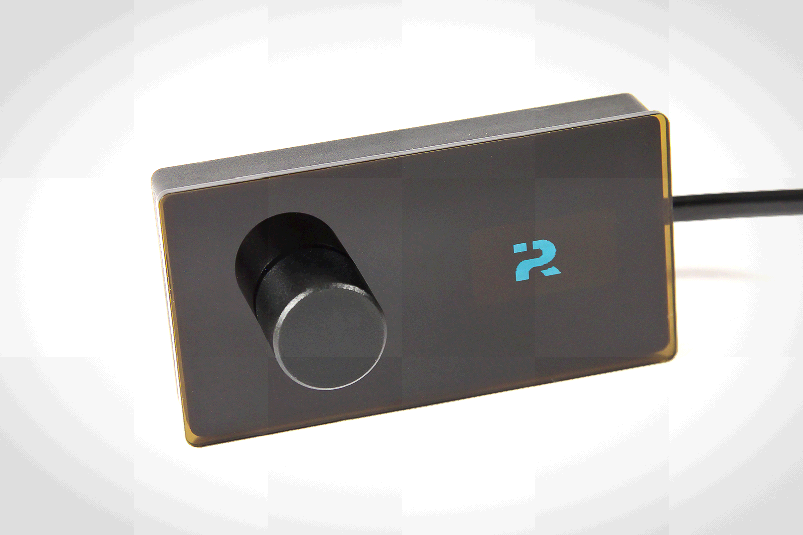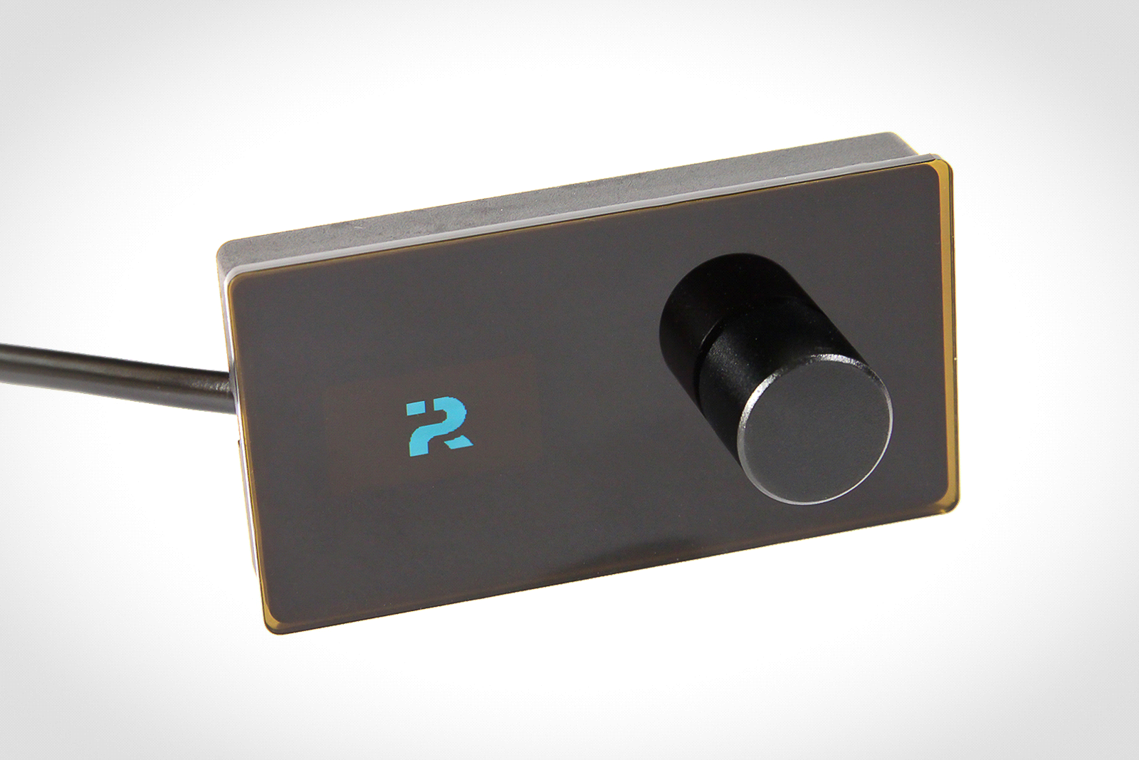

resolut src Work principals

In main operation mode controller displays current level of sound, which can be changed by rotating the encoder.

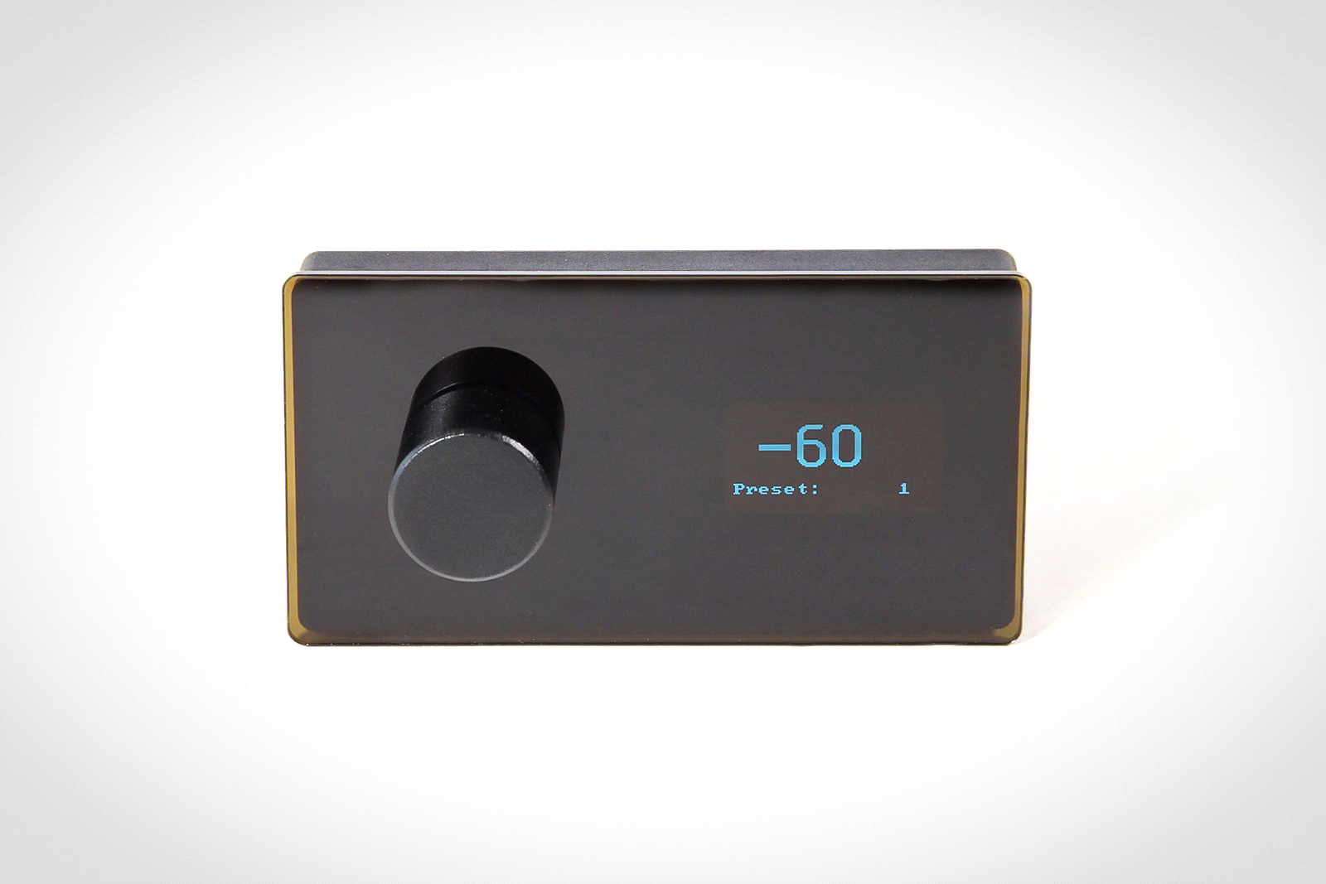

Pressing the encoder activatesfunction menu . In the photo below - the example of menu.. We are continuously improving our product therefore individual elements and details of appearance may differ from what you see on the photos

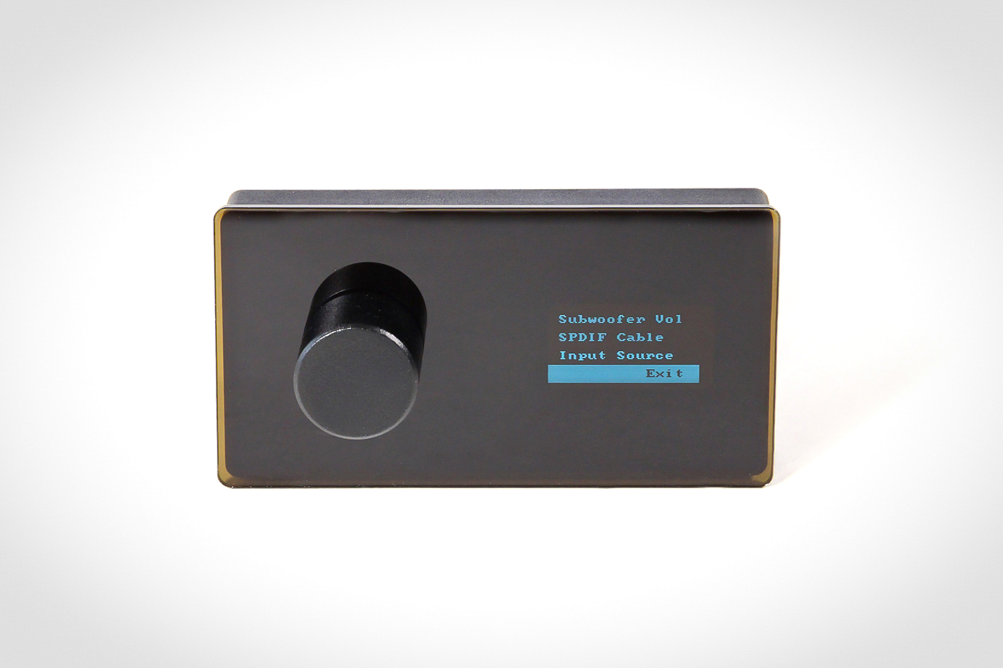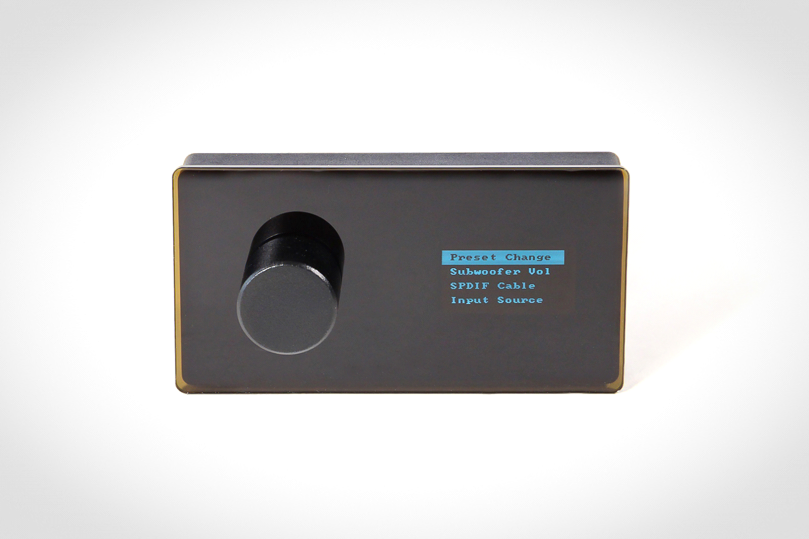

In settings mode you can move between menu options by rotating the encoder . Confirm the option by pressing on encoder after choosing the function (for instance, correct the subwoofer's level, change the source or choose the preset and etc.). Choose functions by rotating and pressing the encoder.

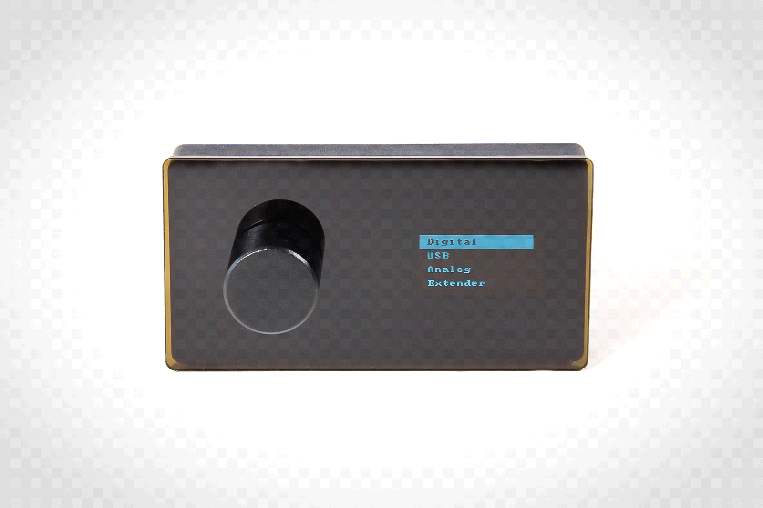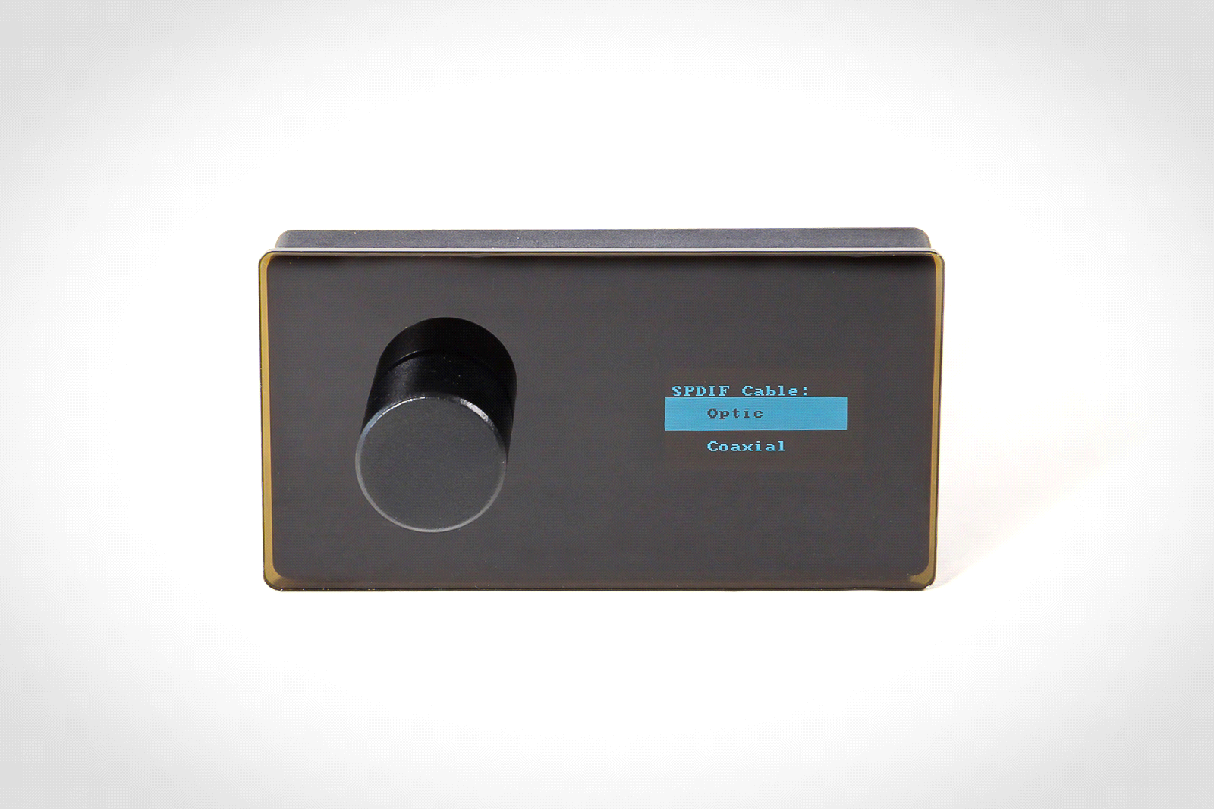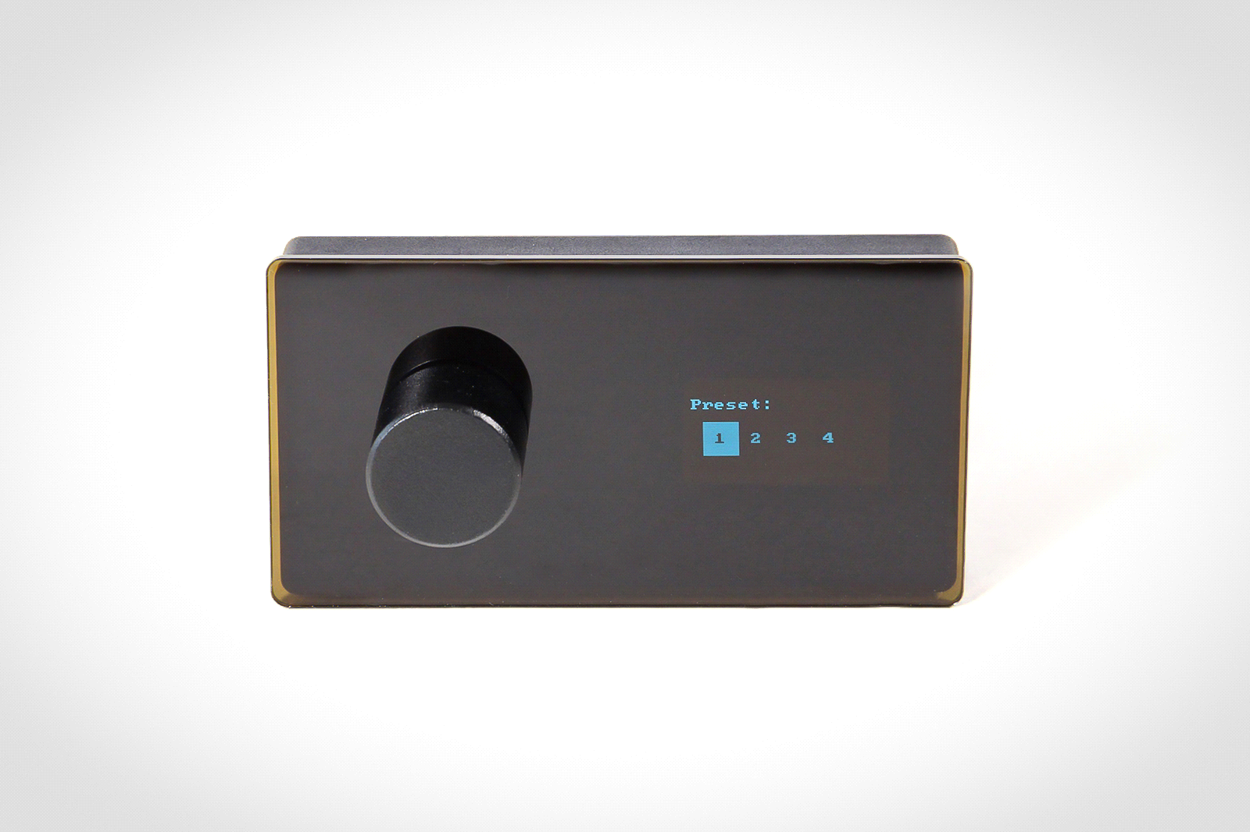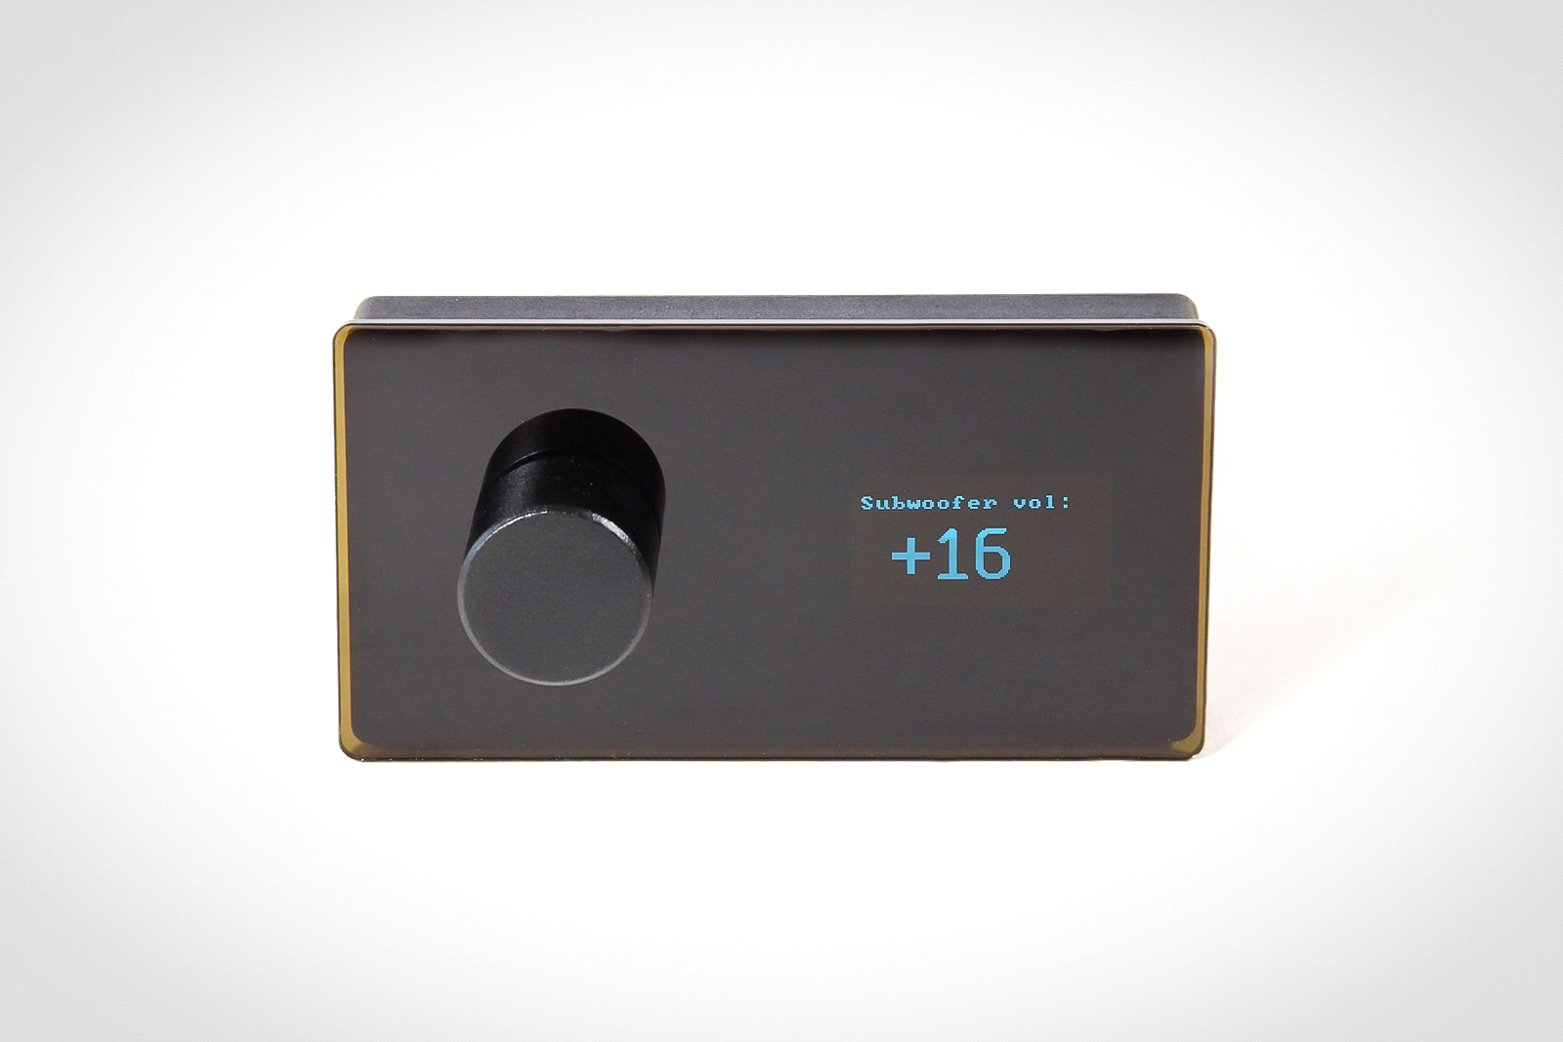

For returning in main mode you can choose Exitand then press the encoder. However, this is not necessary procedure, insofar as the menu of functions is active for a short time, what is enough for unhurried selection of functions. For few seconds of inaction remote controller returns in main mode automatically.

